School: St James Kotara Sth Class: 4W Project name: Water Wise Garden
What was the sustainability issue your school identified? (50 words):___The types of planting in school gardens requires too much water. We designed new garden plantings to achieve greater water efficiency and sustainability. We identified that water is a finite resource and all forms of life on earth depend on it. We identified ways to save it and use it in more thoughtful manner.
The steps you took to solve or improve sustainability at your school
Step 1: __Identify plants with a local provenance which are drought resistant and tolerate less water. We did this research using a number of websites and learning from a local horticulturalist. We gathered a list of suitable plants. We will use water from our rain water tanks to nurture our gardens.
Step 2: We followed the instructions from the expert to prepare the ground for planting. We dug large holes to break up the clay soil added nutrients and water Crystals.
Step 3: __We carried out the planting from our designs and created posters to put around the school. To educate others about the need to conserve water. We spoke to the young classes about this.
The outcome (50 words):____We are happy that our garden looks better and we learned a lot about water. We learned that water is a finite resource and only about 1% of water on earth is useful to us. The rest is frozen or salty. This helped us to want to save water.__________________________________________________________________________________________________________
How can you measure its success? (50 words):___It is very early in our project but as we intend to use only water from our tanks we will judge the success by how well the plants grow and ___and surveying families to see if any have taken up our ideas. We can’t really measure it just yet._______________________________________________________________________________________
How could the project be scaled? (e.g. How the wider (school) community could be involved?) __We will add items in our school newsletter about the _need to conserve water_. We intend to signpost the garden at the front of our school so that local passers-by will know what plants they can plant in their local area to conserve water.__________________________________________________

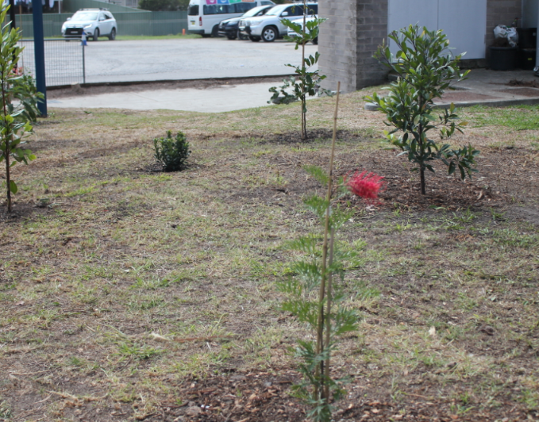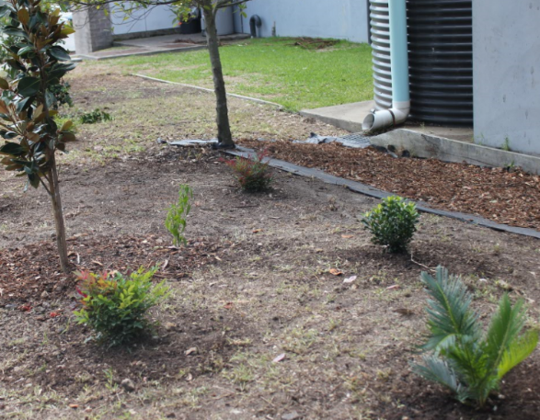

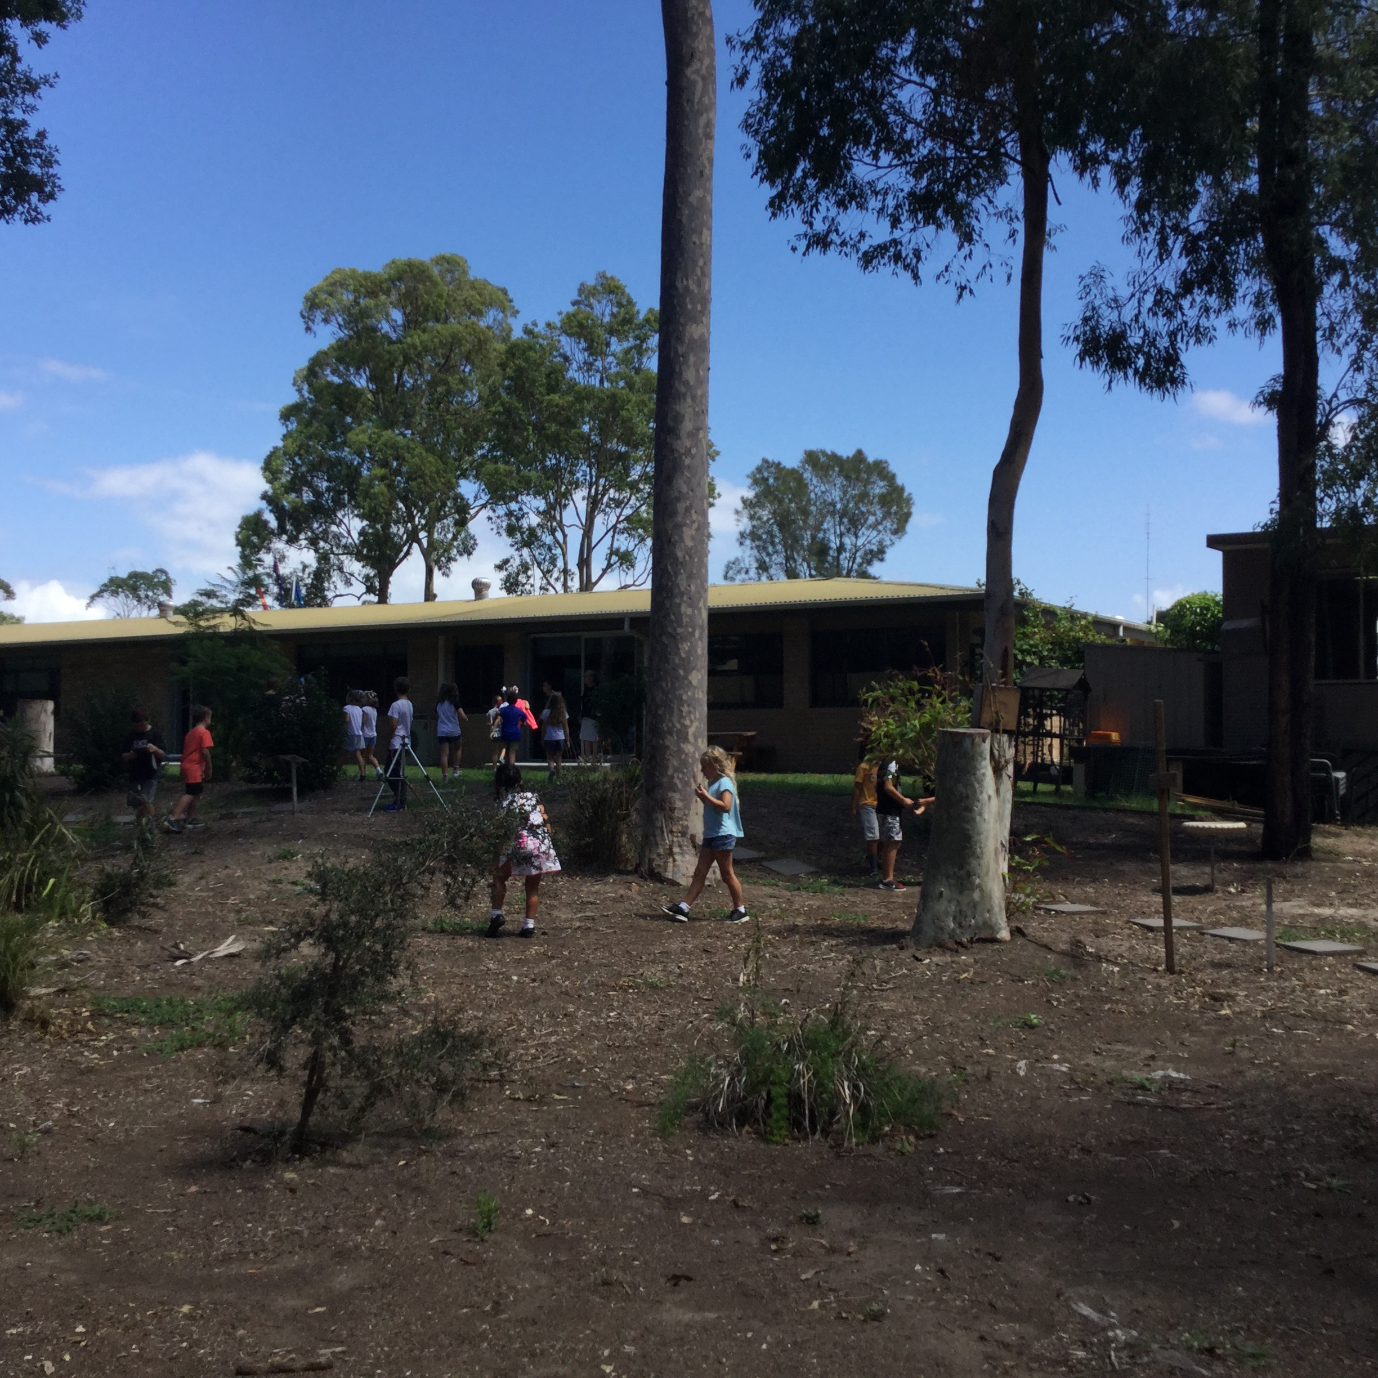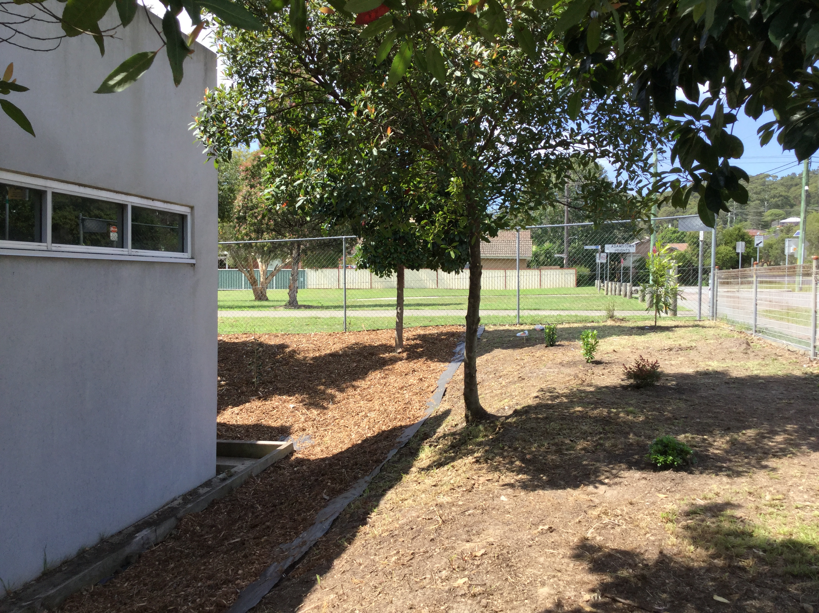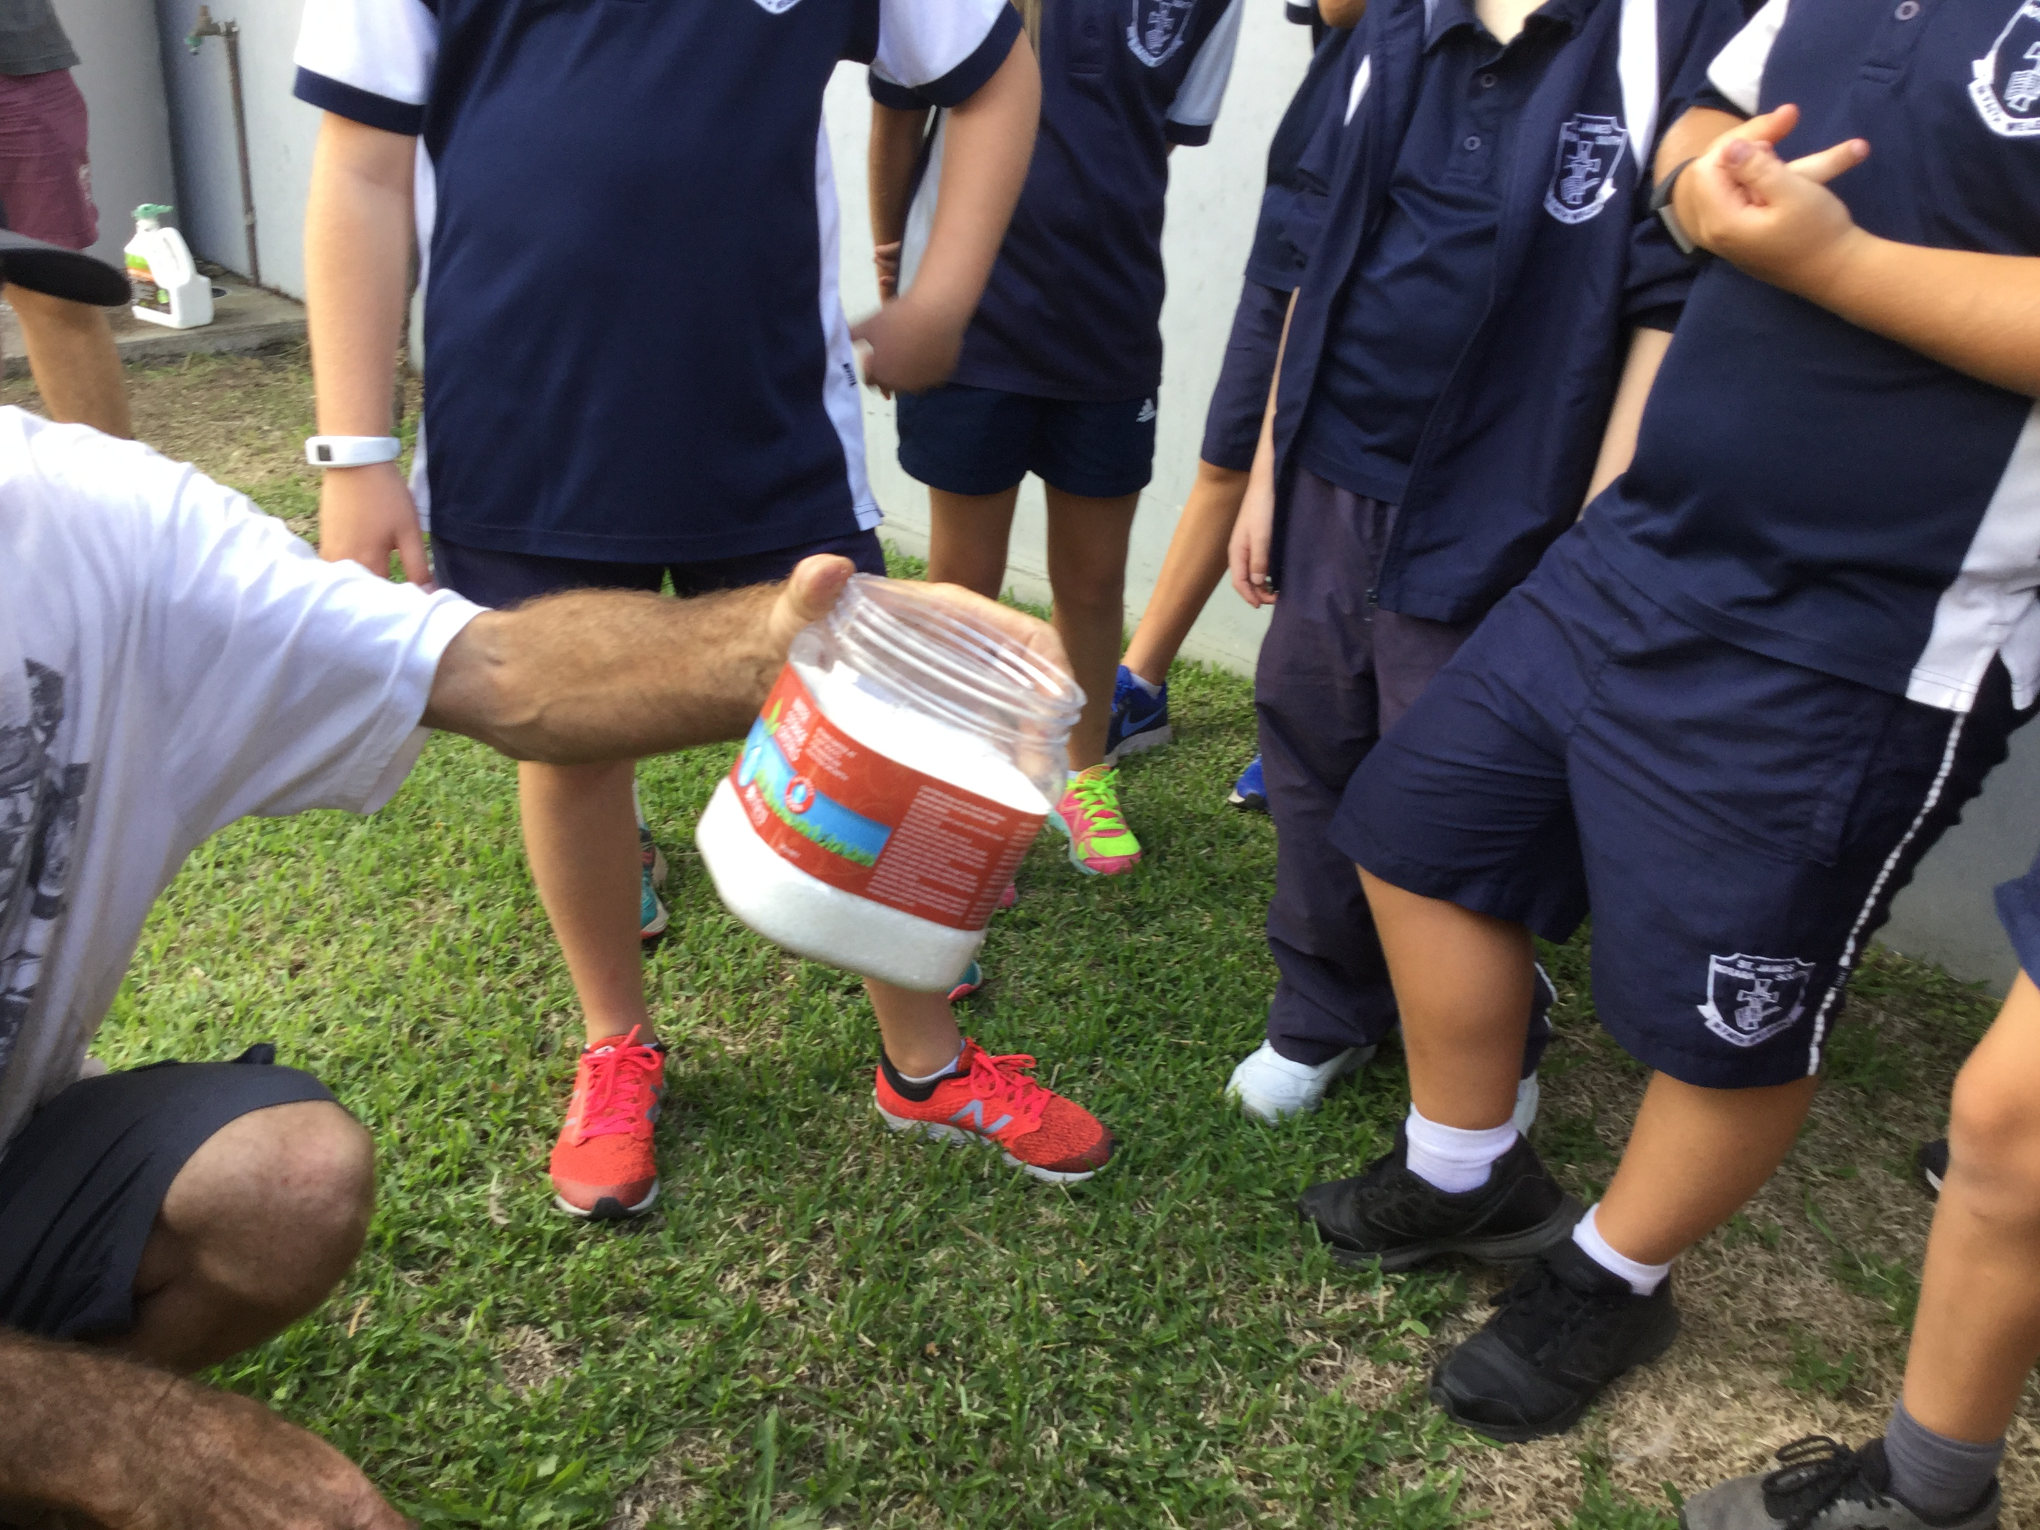

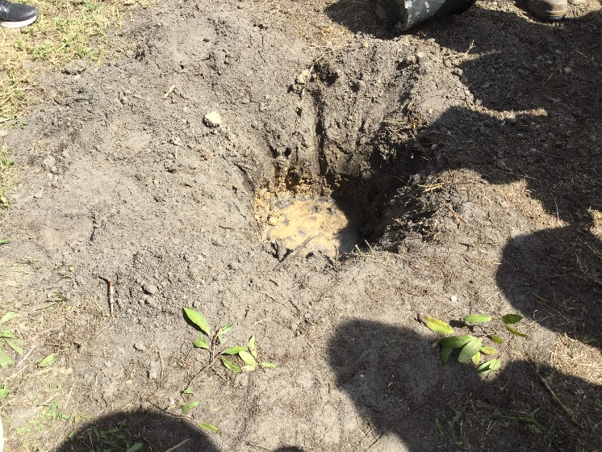

Before photo After photo

