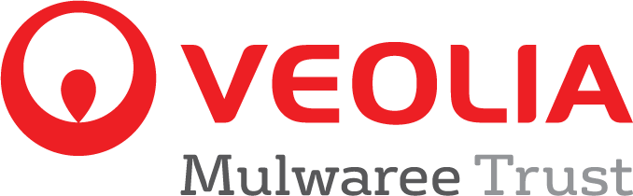

PROJECT REPORT AND GRANT ACQUITTAL
- This form may be competed online by logging to your Smartygrants account

Grant recipient organisation name | Project Title

Grant received from Trust: $ Project reference number:
Project start date: Project Completion Date:

About the project

Tell us what happened with the project?

In your opinion, did this project achieve its objectives?

Yes ☐ No ☐
Why/why not?

Did anything happen that took your project off course or resulted in changes to your original proposal?

Yes ☐ No ☐
If yes, what happened?

How do you think your organisation and/or the wider community have benefited from this project?

Recognition of Veolia Mulwaree Trust funding

How has the grant funding been recognised? Please refer to the terms of your funding agreement for agreed public recognition and attach copies as evidence. Veolia Mulwaree Trust logo is available to download from https://www.veolia.com/anz/about/about-veolia/corporate-social-responsibility/veolia-mulwaree-trust/funding-grants

☐ Local media
☐ Newsletter
☐ Web Site - If yes, please provide web address:
☐ Permanent signage or plaque (the construction sign provided by the Trust is not a permanent sign)
☐ Other, please provide details:

Statement of Project Expenditure

Below, please provide a statement of expenditure showing:

- Details of budgeted and actual amounts expended on the project with copies of invoices attached separately
- Any balance remaining

Expenditure Items | Original Budget | Actual
List of all purchases, costs, materials, labour in-kind etc | Please refer to your original grant application | This column should show what you really spent. Copies of invoices will need to be attached for purchases/materials and professional labour costs.
 | $ | $
TOTALS | $ | $

Total (if any) of unspent Veolia Mulwaree Trust funds $__________________

Photographs

Please provide at least two photos of your project. These should be in JPG format and can be emailed to vmt@veolia.com Photos may be used in the Veolia Mulwaree Trust’s publicity materials and on Veolia’s website. Where possible, photos should show members of your organisation with, or utilising, the item/s funded.

Any additional comments?

Supporting documentation included

Before signing, please ensure the following documents are included. Final payments can only be paid at the completion of all the terms of the Funding Agreement which includes the items below:

☐ 1. Copies of expenditure invoices attached
☐ 2. Copies of media coverage and other publicity attached.
☐ 3. Evidence of permanent plaque or acknowledgement attached
☐ 4. Photographs showing members of the organisation and the finished project (see above).

Declaration

Name of person completing report, signature and date | Position in organisation | Contact phone and email

For assistance in completing this form please call (02) 48222786.
Please return completed form and required attachments to vmt@veolia.com

